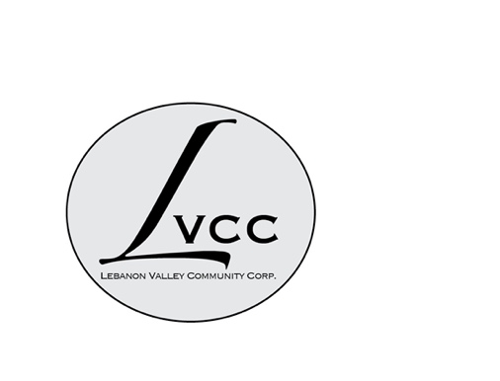
MINUTES OF THE LEBANON VALLEY COMMUNITY CORPORATION (LVCC)
HELD ON June 20, 2024 at Town Hall

Present:
Erminia Rasmussen (President), Gregg Carroll, Sarah Conly, Sharon Powers, Monte Wasch

Advisors Present: Nina Keller, Tistrya Houghtling

Guest: Mark Baumli of the Cemetery of the Evergreens

CALL TO ORDER:
The meeting was called to order at 10:02am by Erminia Rasmussen

MSC: To approve the minutes of the May 9, 2024, meeting was made by Monte Wasch, seconded by Gregg Carroll. Motion approved.

Treasurer’s Report:
We have $10,595.43 in cash. (See attached Treasurer’s report on exact figures.) We received $375 this month as part of our recurring donations, $613 in camp funds. After spending money on 4 campers, we have $2393 left in the summer camp fund

MSC: To approve the Treasurer’s Report was made by Erminia Rasmussen, seconded by Monte Wasch. Motion approved.

MARK BAUMLI
The cemetery is a 501C (13) which is why the Cemetery of the Evergreens (The Cemetery) grant came through the LVCC. The Cemetery wants to give money back to the LVCC to hold – they had received a donation of $10,000 to make their total go to $16,130 collected. LVCC collected $3000 which totaled $19,130. After The Cemetery had the big storm, they spent $15,450 on tree service to Cassidy plus $1200 to Saviano – there was extensive damage. The Cemetery will keep $3000 of the $16,000 and will give the LVCC $13,000 of funds collected. No money can be spent from the LVCC unless they have approval of two members of The Cemetery board – two of the three people: Ed Godfroy, Joanne Amlaw or Mark Baumli.

SURVEY
The survey questions will be arranged in general categories and be available online and in print. Erminia will send the printed copy to David McGinness for distribution. We want to get this out soon so it is not confused with the Columbia County office of Aging survey that is due to go out as well. We agreed that you do not have to be a senior to volunteer. Will remove the word “senior” from the survey.

SYP STATUS
We paid for four kids and have about $2400 left. Discussed whether or not we should include field trips and swimming lessons. It was decided not to pay for field trips but to pay for swim lessons for one session. Want to see if we could pay for swimming lessons for all children at camp.

MSC: by Erminia Rasmussen to assign Gregg the task of calling Tim who runs the program and see what it would take for the LVCC to sponsor swim lessons and to authorize the LVCC to make up any shortfalls if we feel we can afford it. Seconded by Monte Wasch. Motion approved.

GRANTS
We were rejected by the Reeve Foundation. Still applying for the B’nai Brith grant. Just applied for Bank of America grant. Kabota Grant we will find out in late July if we are a worthy project and then will have to get people to vote for us.

MSC: To adjourn the meeting at 10:58 was made by Erminia Rasmussen and seconded by Gregg Carroll. Motion approved.

Next meeting: July 11, 2024 at 10am.

Respectfully submitted,

Sharon Powers
Secretary

