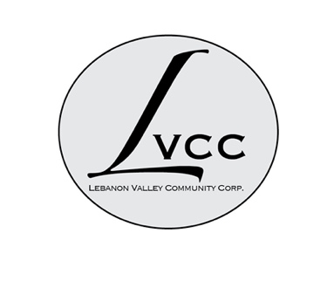
MINUTES OF THE LEBANON VALLEY COMMUNITY CORPORATION (LVCC)
HELD ON September 18, 2025 at the New Lebanon Town Hall

Present:
Dorothy Lamonaca (Vice-President), Sharon Powers, Susan Tipograph, Sarah Conly

CALL TO ORDER:
The meeting was called to order at 10:00 am by Dorothy Lamonaca, who was presiding over the meeting in Erminia Rasmussen’s absence. A quorum was present.

MSC: to approve the minutes from the August 14, 2025 meeting was made by Sharon Powers and seconded by Susan Tipograph. Motion approved.

TREASURER’S REPORT – presented by Dorothy Lamonaca
Dorothy is still working through the accounting software and will give an update to Tistrya on the playground funds brought in thus far. Discussion about sending a check to the food bank with money as of end of September.

MSC: To approve the Treasurer’s report was made by Sharon Powers and seconded by Sarah Conly. Motion approved.

Also discussed the EFT Corporation and them handling the donations instead of PAYPAL. We need to get this set up now so we are ready for the Holiday Gift Drive.

Dorothy would like us to figure out what our new fixed costs are going forward at a future meeting.

MSC: To approve the new EFT system was made by Susan Tipograph and seconded by Sarah Conly. Motion approved. Dorothy will get a final ok from Erminia before proceeding.

Seniors Update (by Sarah Conly)
She spoke to the LV Seniors and got a positive response about the Neighbors of Columbia County (NCC) program. Will have an info session for NCC at a future LV Seniors meeting. The Seniors Survey from CC has gone out from the Office for Aging – hope to have as many people fill it out as possible. It’s due on October 10 – doesn’t require a name, data goes to Columbia Greene CC who will put it together. The meals in the fridge from the Columbia County Recovery Kitchen are now up to 40.

THANK YOU NOTES & GRANTS (Susan Tipograph)
Are going out as usual. In January, Dorothy will do the letter showing total giving for the year to each person who donated. Susan submitted an application to the Honest Weight Food Co-Op in Albany on September 7 and will let us know when she hears back. The Berkshire Taconic Arts & Humanities Fund is not for us, but for students, teachers in New Lebanon. She will also work on Bank of Greene County.

NEXT MEETING: October 16, 2025, 10:00am, at Town Hall.

MEETING ADJOURNED: 10:45am

Respectfully submitted,

Sharon Powers
Secretary

_________________________________________________________________________________________

REPORTS FROM LVCC PROJECTS:

GROW THE VALLEY (Sharon)
Report on Grow the Valley (GTV)
September GTV
Sent to 848 recipients
51.9% Open Rate (438 people), 9.2% clicks, 4 people unsubscribed
Top 5 clicked
- Darrow School mountain bike trail
- Donate to Backpack Fund
- LVCC website
- Poster on the Backpack Fund
- Canaan Historical Society poster
August GTV:
Sent to 851 recipients
51.9% Open Rate (441 people), 7.5% clicks, 2 people unsubscribed
Top 5 clicked
- LVCC website
- The Abode programs
- Night Lights in New Lebanon poster
- The Community Center poster
- August Events at your Library
July GTV:
Sent to 854 recipients
52.2% Open rate (443 people), 5.8% clicks, 1 person unsubscribed
Top 5 clicked
- LVCC website
- Night Lights in New Lebanon (August)
- Donate to Shatford Park link
- Punk & Puke Fundraiser event (August)
- Robin Catalano yoga class
June GTV:
Sent to 852 recipients
47.2% Open rate (400 people), 11% clicks, 1 person unsubscribed
Top 5 clicked:
- Chatham to Hudson bus Route
- Robin Catalano yoga class
- Twin Wolves Healing Arts Blood Tea & Red String
- The Abode programs
- Night Lights in New Lebanon (August)

