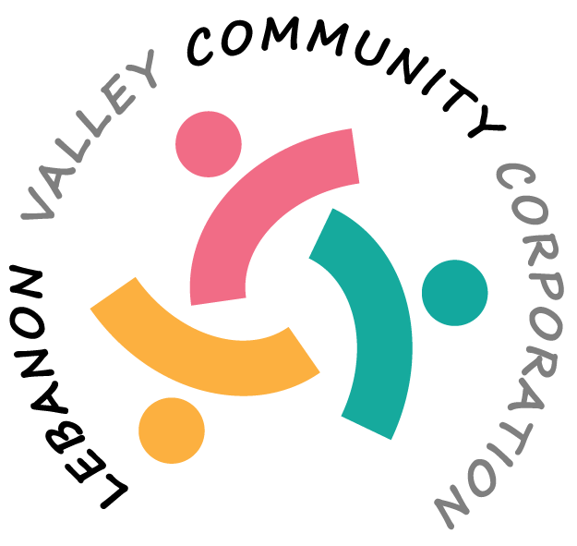

MINUTES OF THE LEBANON VALLEY COMMUNITY CORPORATION (LVCC)
HELD ON October 16, 2025 at the New Lebanon Town Hall

Present:
Erminia Rasmussen, Dorothy Lamonaca, Sharon Powers, Susan Tipograph, Sarah Conly

CALL TO ORDER:
The meeting was called to order at 10:03 am by Erminia Rasmussen. A quorum was present.

MSC: to approve the minutes from the September 18 meeting was made by Sharon Powers and seconded by Erminia Rasmussen. Motion approved.

TREASURER’S REPORT – presented by Dorothy Lamonaca
Dorothy needs a motion to authorize her sending $1400 to the food bank for the backpack program.
MSC: To approve sending $1400 to the Regional Food Bank for the Backpack Program was made by Dorothy Lamonaca and seconded by Erminia Rasmussen. Motion approved.

We also received a donation for art supplies for the high school of $250.00. She will be sending this to the New Lebanon Central School District.

MSC: for Dorothy to send a check to the NLCSD in the amount of $250 to be applied toward art supplies for the Jr/Sr High School was made by Susan Tipograph and seconded by Sarah Conly. Motion approved.

Sharon Powers will check with the school at the next school board meeting regarding their future needs for Art Supplies or anything else.

Discussion was held about the LVCC’s overhead costs so we could get an idea of our yearly costs. These were the costs we came up with
- EFT (credit card processing) – cannot predict since it’s based on monies that come in
- Directors & Officers Insurance - $616/year
- Accounting program - $300/year – might drop this
- Grant Station $119/year – decided to drop this for next year
- Mailchimp $28/month
- Mailbox at post office – approximately $75/year
- Website hosting & domain name – about $250/year

We are hoping to keep overhead to around $1000 per year

CYPRESS HILLS
Progress report was submitted on October 15. Mark Baumli and Joanne Amlaw said stone repair should be done this week, after the October report. We talked about continuing to raise money for the cemetery and agreed to still do so but are reluctant to take on any more grants for them. Dorothy will do a follow-up with Mark Baumli about what they want to do with the money we hold for them.

BACKPACK PROGRAM – presented by Erminia Rasmussen
Erminia spoke with a woman from the Food Bank program and then met in person with Pat Metzler and Michele Bienes who run the program. Every donation to the Food Bank gets designated to New Lebanon and then the school is notified. The school decides how many kids to cover and now cost $289/each. For this year, they had $8435 in the account, and this covered 30 kids. They receive donations from individuals, the Woman’s Club of New Lebanon and had a grant of $20,000 from years ago that has been used up now. They currently had 5 kids on a waiting list. Erminia spoke with the LVCC $10,000 donor and told them the current situation and the 5 on the list and proposed that we use it to take them off the waiting list and apply the balance for next year so it’s there for them. The donor agreed. Erminia asked how many kids need it and they said about 50 could use it but many won’t because once they get to Middle and High School they are embarrassed to receive it. Wondered if we could work with the school and deliver the food?

Erminia told Pat Metzler that if there is a change she should let us know.

MSC: To transfer the special donation of $10,000 to the Regional Food Bank / Backpack Program and earmark it for the NLCSD was made by Erminia Rasmussen and seconded by Susan Tipograph. Motion approved.

MSC: To transfer $1842 in our designated backpack fund to send to the Regional Food Bank / Backpack Program was made by Susan Tipograph and seconded by Dorothy Lamonaca. Motion approved.

General Fund – we need to move some money to support programs from the general fund. Right now we support two scholarships, $250 for the fire disaster relief, plus $250 each to disaster relief on two cards, and a donation to the Cypress Hill Cemetery of $350.00. Perhaps we can donate to art supplies or the Columbia County Recovery Kitchen. Erminia will check with Tistrya about snack donations to the Community Center. Another possibility is the Just Food club.

SENIORS UPDATE – presented by Sarah Conly
The Neighbors of Columbia County will be scheduling a time to talk to the Seniors. Perhaps the LVCC could provide a subsidy to seniors toward the $75/year membership fee. Hoping to try for November meeting.

HOLIDAY GIFT DRIVE
Will be our next project. Will be announced in the November Grow the Valley. Tistrya will give us a poster with the details. We hope to have the new software in place to accept those donations.

NEW LOGO
Sharon presented a new logo and letterhead to the group that we will use in the future. Logo appears on page one of these minutes and will be updated on our donation forms and web pages.

APPEAL LETTERS
Nina suggested to send out 4 letters, perhaps 5
#1 - November 1 – about the holiday gift drive – to people who have donated in the past. The letter has been drafted, just need some more info on it
#2 – Sent at beginning of December to people that give to the general fund – the monthly donation – a thank you to the monthly people telling them where the money has been spent
#3 – March – letter introducing us to people who don’t know us – can use the emails from GTV – excluding the holiday gift drive and general fund people – will go as an email
#4 – summer camp – send in April – appeal letter to those who have donated to it in the past
#5 – to the Backpack people – perhaps in July preparing for the next school year

To keep costs down, we will all print the letters on personal printers and address the envelopes manually

THANK YOU NOTES
Thank you to Susan for sending them out on our behalf – she is all caught up.

INSURANCE
We got a sample of the policy from Metzwood (Great American Insurance Company) and Marshall & Sterling (too costly for us) – for $1million – Susan will check if the yearly fee would be less if we do not have employees.

MSC: To purchase the Board of director’s Insurance from Great American Insurance Group for a $1million policy for approximately $616, to be used from the General Fund, and be effective on or about November 1 was made by Erminia Rasmussen and seconded by Susan Tipograph. Dorothy Lamonaca will be the officer in charge of this and will sign as needed. Motion approved.

INCLUSIVE PLAYGROUND
Tistrya reported via Erminia – she would like us to create a press release about this. The bids came in below the budget so they can afford all the renovations plus all of the equipment.

NEXT MEETING: November 13, 2025, 10:00am, at Town Hall.

MEETING ADJOURNED: 11:54pm

Respectfully submitted,

Sharon Powers
Secretary

_________________________________________________________________________________________

REPORTS FROM LVCC PROJECTS:

GROW THE VALLEY (Sharon)
Report on Grow the Valley (GTV)
October GTV
Sent to 844 recipients
58.4% Open Rate (492 people), 10.9% clicks, 0 people unsubscribed
Top 5 clicked
- Acceptable plastic to recycle
- LVCC website
- Senior survey
- Request an Early Mail Ballot
- October events at the library
September GTV
Sent to 848 recipients
53.4% Open Rate (451people), 9.7% clicks, 4 people unsubscribed
Top 5 clicked
- Darrow School mountain bike trail
- Donate to Backpack Fund
- LVCC website
- Poster on the Backpack Fund
- Canaan Historical Society poster
August GTV:
Sent to 851 recipients
51.9% Open Rate (441 people), 7.5% clicks, 2 people unsubscribed
Top 5 clicked
- LVCC website
- The Abode programs
- Night Lights in New Lebanon poster
- The Community Center poster
- August Events at your Library
July GTV:
Sent to 854 recipients
52.2% Open rate (443 people), 5.8% clicks, 1 person unsubscribed
Top 5 clicked
- LVCC website
- Night Lights in New Lebanon (August)
- Donate to Shatford Park link
- Punk & Puke Fundraiser event (August)
- Robin Catalano yoga class
June GTV:
Sent to 852 recipients
47.2% Open rate (400 people), 11% clicks, 1 person unsubscribed
Top 5 clicked:
- Chatham to Hudson bus Route
- Robin Catalano yoga class
- Twin Wolves Healing Arts Blood Tea & Red String
- The Abode programs
- Night Lights in New Lebanon (August)

