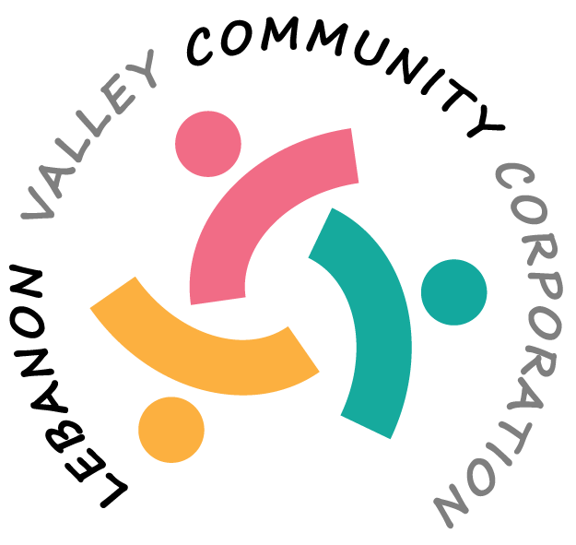

MINUTES OF THE LEBANON VALLEY COMMUNITY CORPORATION (LVCC)
HELD ON February 20, 2026, at New Lebanon Town Hall

Present:
Erminia Rasmussen, Dorothy Lamonaca, Sharon Powers, Sarah Conly

Advisors Present:
Nina Keller

CALL TO ORDER:
The meeting was called to order at 10:11 by Erminia Rasmussen. A quorum was present.

MSC: to approve the minutes from the December 11 meeting was made by Sharon Powers and seconded by Sarah Conly. Motion approved.

TREASURER’S REPORT – presented by Dorothy Lamonaca
Largest sources of income in 2025 were the holiday gift drive, food bank and playground. Next year the tech line will be less, as will the ZOOM expense as it was canceled. Into 2026, we will need more information for donations and acknowledge those. Our receipts in the past had been less than $50,000 but this year they were more so we have to do a 990 form instead of a postcard. We should have a discussion about the Holiday Gift drive and how to proceed next year when Tistrya Houghtling is present at the meeting. Also need to find out about the Amazon business account. Will have a meeting in April to discuss the holiday gift drive – hopefully April 16 at 10 am.

Status of DAR Grant – still waiting for the money from them.
Change of Donor Page – from EFT – the pop-up comes up after they choose credit card, to ask if they want to pay the credit card fees. Should we ask to change that or leave it?

A discussion about including people’s names on the online donor list – something like “We appreciate your generous donation and want to include your name on our donor list.” Or should we ask a more direct question: Can we add your name (not including the amount) to our online donor list.

Agreed to include a line in the next Grow the Valley about this – something like “If you have donated by cash or check and it’s ok to be listed on the donor page, contact Sharon Powers.”

THANK YOU CARDS
Now sent out once a month. Agreed we should send them out quarterly instead

MSC: To change thank you cards to quarterly instead of monthly was made by Sarah Conly and seconded by Dorothy Lamonaca. Motion approved.

APPEAL LETTERS
Nina said we have done the Holiday gift drive, general fund letter and now need the camp letter, which should go in the Grow the Valley April edition. Say that we have approved 8 children but want to sponsor more and include swimming lessons and trips for them. Camp program application works well with overage being applied to the next year. Will have an email blast in GTV and a letter sent to the 20 people who gave to the camp before.

JOSH EMAIL
Josh Young asked if the LVCC could sponsor the collecting of the donations for the SNAP program. No grants are being applied for. He has shoppers who want to contribute, and they need a conduit to collect the money. We need to find out to whom the money will be sent. Dorothy Lamonaca will follow up with Josh.

NEW FORMS FOR FISCAL SPONSORSHIP
Sharon will make an interactive document for the application. Keep in mind that LVCC is always a fiscal sponsor, not a pass-through.

In the future, LVCC will charge 2% administrative fees for grants for which we are the fiscal sponsors but nothing if we are just collecting monetary donations. We went over the policies and made suggested changes, which Erminia will incorporate into the documents. Suggested we split the agreement into monetary donations vs grants.

NEXT MEETING: Next meeting will take place March 25 at 10am at Town Hall. April’s meeting will be on April 16 at 10am.

Respectfully submitted,

Sharon Powers
Secretary

_________________________________________________________________________________________

REPORTS FROM LVCC PROJECTS:

GROW THE VALLEY (Sharon)
Report on Grow the Valley (GTV) from last 6 months
February GTV
Sent to 821 Recipients
60.8% Open Rate (496 people), 8.7% clicks, 2 people unsubscribed
Top 5 clicked
1. Comprehensive Plan Form
2. LVCC webpage
3. February events at the library
4. WBH registration for pre-K
5. Detox the mind through meditation
January GTV
Sent to 822 Recipients
59.7% Open Rate (488 people), 9.4% clicks, 1 person unsubscribed
Top 5 clicked
1. January events at the library
2. January repair cafes list
3. LVCC webpage
4. Repair cafes of the Hudson Valley
5. NY State ASsociation for Reduction, Reuse and Recycling
December GTV
Sent to 823 Recipients
62.0% Open Rate (508 people), 6.6% clicks, 2 people unsubscribed
Top 5 clicked
1. Neighbors Helping Seniors Thrive
2. Rumi Concert and dinner at the Abode
3. Donate page for LVCC
4. December events at the library
5. Soul of Love celebration at Darrow (celebrating Rumi)
November GTV
Sent to 820 recipients
58.9% Open Rate (480 people), 7.5% clicks, 0 people unsubscribed
Top 5 clicked
1. LVCC website
2. November events at the library poster
3. Robin Catalano yoga poster
4. Just Food Club Thanksgiving dinner poster
5. 10th Annual Gift Drive poster
October GTV
Sent to 844 recipients
59.5% Open Rate (501 people), 11.3% clicks, 0 people unsubscribed
Top 5 clicked
- Acceptable plastic to recycle
- LVCC website
- Senior survey
- Request an Early Mail Ballot
- October events at the library
September GTV
Sent to 848 recipients
53.6% Open Rate (454 people), 9.7% clicks, 4 people unsubscribed
Top 5 clicked
- Darrow School mountain bike trail
- Donate to Backpack Fund
- LVCC website
- Poster on the Backpack Fund
- Canaan Historical Society poster

